## Aboriginal Needs

The Aboriginal Needs goal was defined by Daigle et al. (unpublished) for use at the national scale. Here we explain the national approach, apply that approach to the MRPA, and give recommendations for future applications of the Aboriginal Needs goal at a regional scale.

## National Approach

The original OHI goal of ‘Artisanal Fishing Opportunities’ meant to reflect the ability to conduct sustainable, artisanal-scale fishing when the need is present. Artisanal fishing was defined fisheries involving households, cooperatives or small firms that use a small amount of capital and energy and small fishing vessels (if any), make relatively short fishing trips, and use fish mainly for local consumption or trade (Halpern et al. 2012a, b). Artisanal fishing may happen under a commercial license (e.g., a family-run boat or individual shellfish harvesting permit), or under a recreational fishing permit (e.g., families fishing with rods for fish to eat). Importantly, this goal is about the opportunities to carry out such activities rather than about the quantity of food they provide.

While several forms of artisanal fishing occur in Canada, it is most prevalent among Canadian aboriginal communities. Indeed, the Canadian constitution has enshrined the right of Canadian aboriginal people to fish and hunt for food, social and ceremonial purposes, which takes precedence over commercial and other interest (Supreme Court of Canada 1990). Our new goal ‘Aboriginal Needs’ represents extent to which Canada’s Aboriginals are able to access ocean resources for subsistence, social and ceremonial purposes. This goal is based on the physical access to the resources, and the financial factors that determine how many individuals participate in a traditional hunt or fisheries.

Ice cover was identified as a critical variable in limiting physical access to traditional hunting and fishing grounds for Canadian Aboriginals (Inuit Circumpolar Council - Canada 2008, Downing and Cuerrier 2011). Sea ice areal extent was quantified for a 300 km radius for each Canadian Aboriginal community using the National Snow & Ice Data Center Sea Ice Index (Fetterer et al. 2013).

The primary factors in terms of financial incentive are related to the cost of participating in a traditional hunt or fisheries relative to the price of purchasing food (Downing and Cuerrier 2011). The price participation was based on the price of fuel (Statistics Canada 2014) for snowmobiles, boats, and all-terrain vehicles. The estimated price of food for Inuit communities was based on the Revised Northern Food Basket (RNFB), which quantifies the price of purchasing a nutritious diet for a family of four in northern communities (Aboriginal Affairs and Northern Development Canada 2010).

The Aboriginal Needs (AN) index a population weighted mean of the AN score for each aboriginal community and is calculated as:

|  |  |  |
| --- | --- | --- |
|  | $$AN= \sum_{i=1}^{n}{\frac{P_{i}}{P_{tot}}×\frac{{F_{i}}/{G_{i}}}{{{Fb}_{i}}/{{Gb}_{i}}}} ×\frac{I_{i}}{{Ib}_{i}}$$ | (2) |

where *Pi* and *Ptot* are the population in community *i* and the population sum for all communities, respectively; *Gi* is the price of gas (cents per litre) in the nearest major city (Statistics Canada 2014); *Ii* is the average yearly percent ice cover in a 300 km radius circle around community *i*; and finally, *Fbi*, *Gbi* and *Ibi* are the 1979 baseline levels for food, gas and ice cover respectively. This means that the AN is set to 1 in 1979 and decreases as ice cover decreases and/or the price of gas increases relative to the cost of the Revised Northern Food Basket. If *Ii* was 0 for the entire time series, *Ii* ÷ *Ibi* was set to 1. In these cases, there was no decrease in availability of ice cover for hunting and fishing near those aboriginal communities; therefore, there is no decrease in AN due to ice.

## From national to local scale

To use the same approach on a local scale, one must select which aboriginal communities to include as potential users of the area of interest. For this assessment we chose to include all First Nation communities within a 150 km buffer of the MRPA (Figure 1). The Aboriginal Needs score for each of these 9 communities (Figure 2) can then be imported to provide a picture of the situation in each community. However, since they are all in relatively the same area as compared to the national level, there is little variability between communities. The overall Aboriginal Needs score for the MRPA (Figure 3) is calculated using a population weighted mean of the 9 community based scores from the national approach as described above.

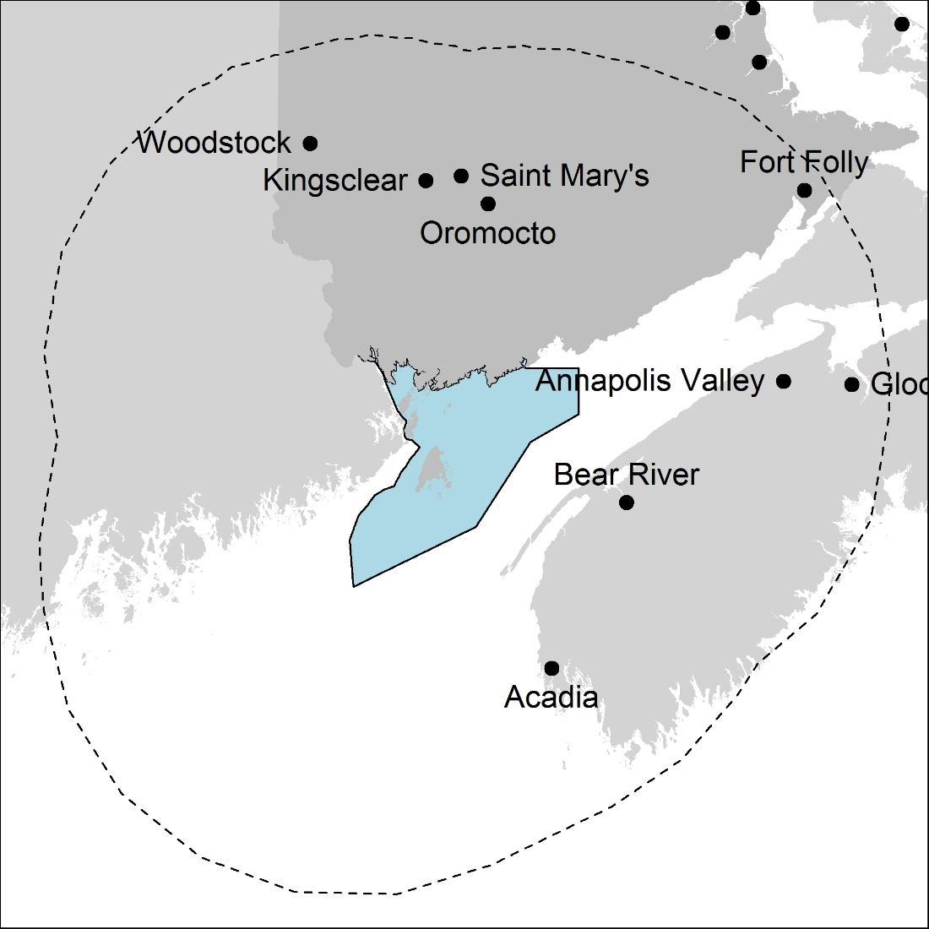

**Figure 1**: Map of the Bay of Fundy and surrounding area showing the local First Nations communities. The blue polygon is the MRPA and the dotted line is the 150 km inclusion limit

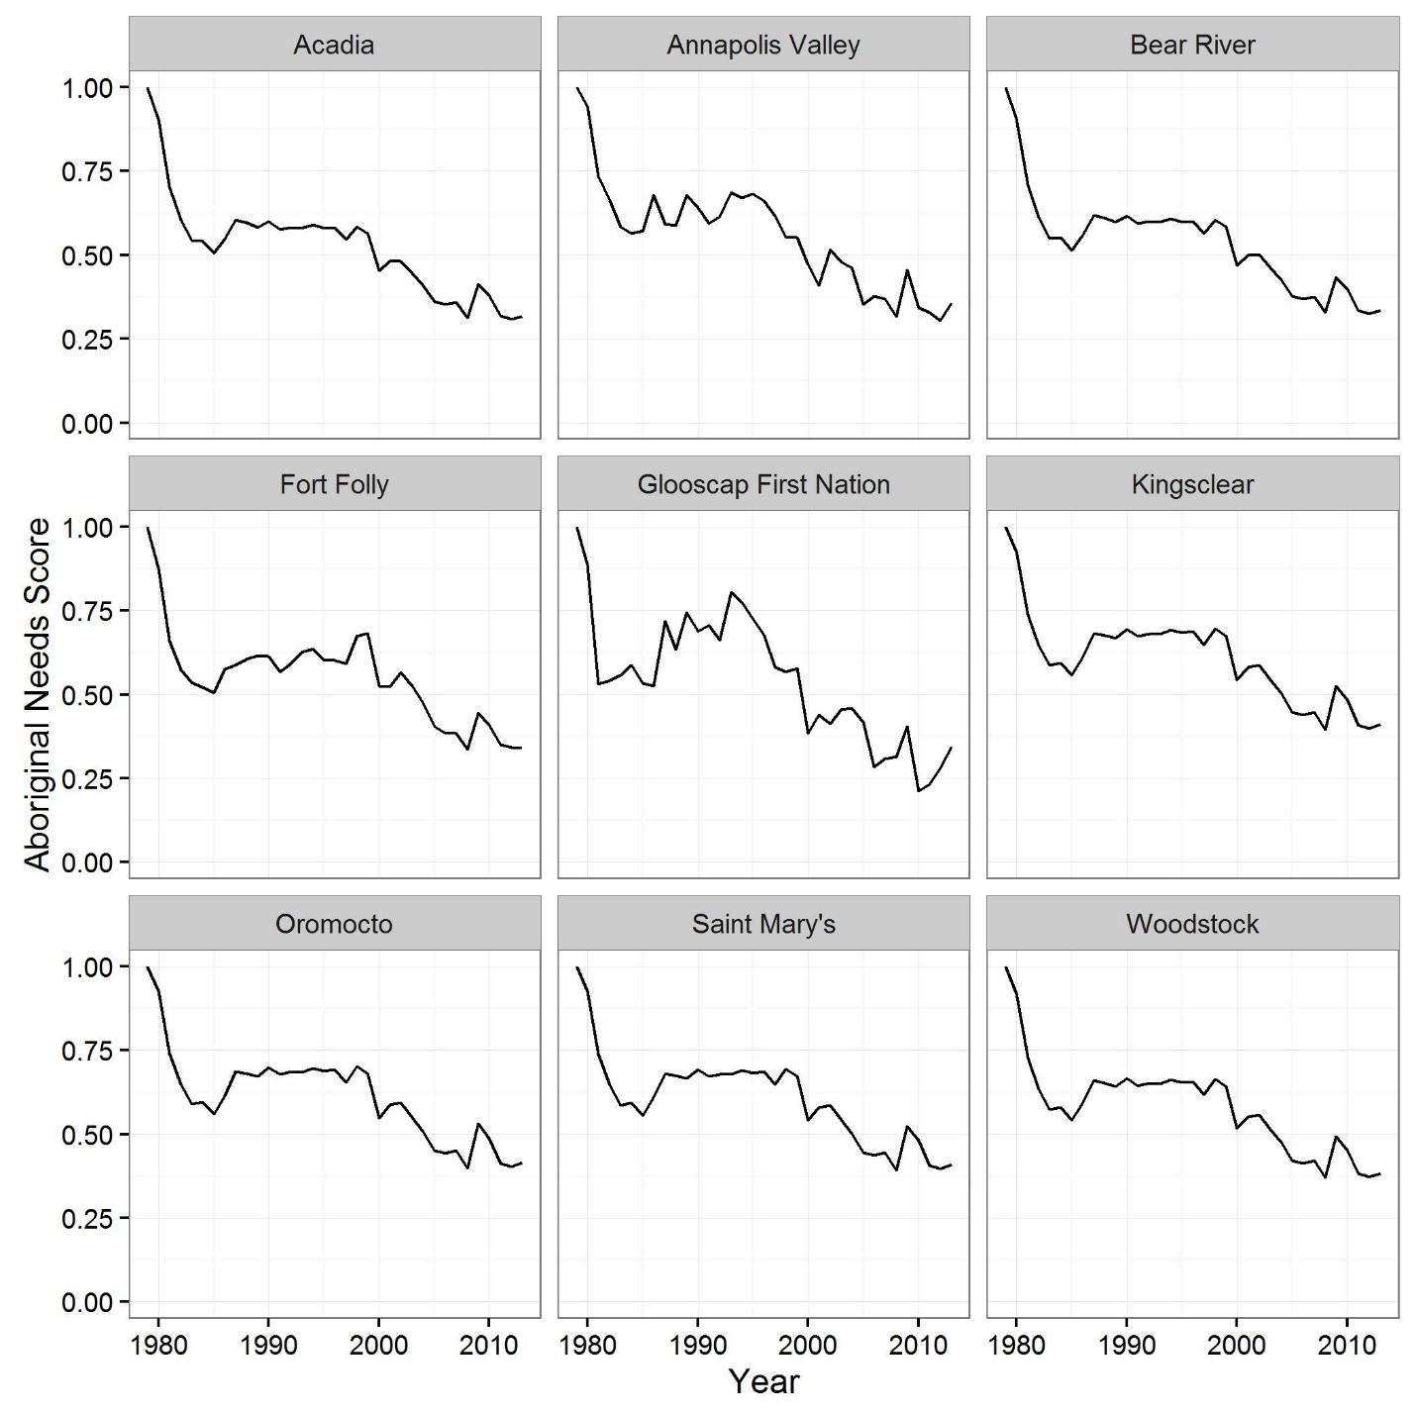

**Figure 2:** The Aboriginal Needs score over time for the 9 First Nation communities included in the analysis.

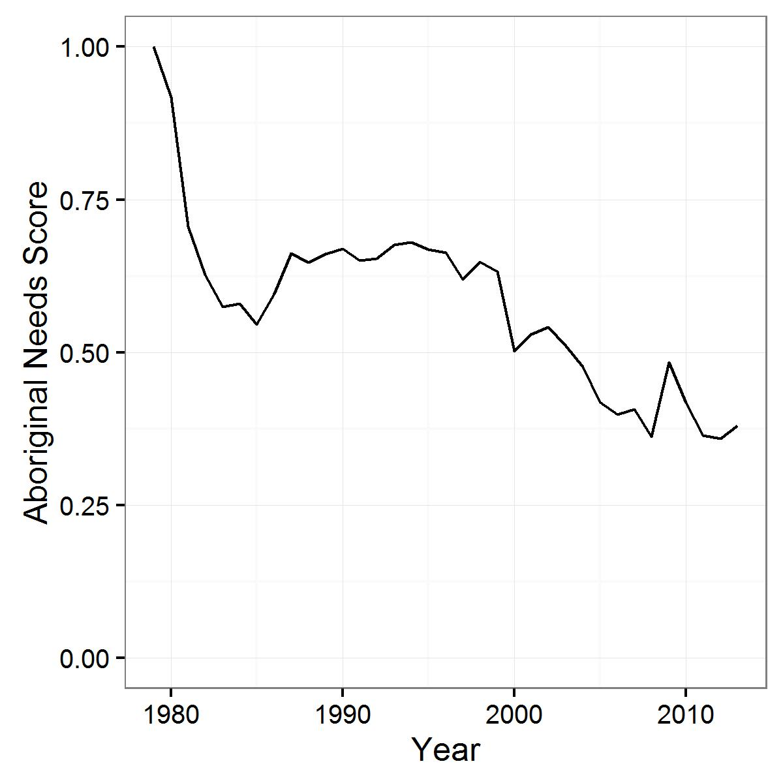

**Figure 3:** The population weighted mean Aboriginal Needs score over time for the 9 First Nation communities included in the analysis.

## Future Directions

The ‘local’ approach described above is somewhat flawed in providing a representative metric of the original definition of the goal Aboriginal Needs: “The extent to which Canada’s Aboriginals are able to access ocean resources for subsistence, social and ceremonial purposes”. These flaws are accentuated when scaling further down from the national level. For example, one of the driving variables of the current Aboriginal Needs goal is relative ice cover as is provides means of transportation for Inuit and First Nations hunters and fishermen (Inuit Circumpolar Council - Canada 2008, Downing and Cuerrier 2011). However, the Bay of Fundy remains mostly ice free year round and so relative ice cover is not relevant for First Nation’s access to ocean resources.

In future assessments, the data used to calculate the Aboriginal Needs score should be customized to more accurately represent the original definition. While ice cover may not be applicable to First Nations near the Bay of Fundy, the underlying mechanism of the effects of climate change limiting access to traditional ocean resources still applies. Climate change affects the availability and behaviour of the traditional food source, increases the incidence of disease, and increases the risk of food spoilage for Canadian aboriginals all of which deeply affect cultural activities, food security, and health (Downing and Cuerrier 2011).

Working directly with First Nations to improve how this metric is calculated will enhance its relevance at the local level. However, customizing the metric to each region will make the metric unusable for comparison across regions. Therefore, developing a customized approach to calculating and Aboriginal Needs score specific to this MRPA would not have been particularly useful. Aboriginal groups involved in DFO’s Aboriginal Aquatic Resource and Oceans Management (AAROM) program could help identify: (1) species of interest, (2) legal or other limitations to access of ocean resources, and (3) regional commonalities. Assessing and incorporating these three aspects would improve the relevance of the Aboriginal Needs goal to local needs while also maintaining the possibility of cross-region comparisons.

## Bibliography

Aboriginal Affairs and Northern Development Canada. 2010. Regional Results of Price Surveys. Available from http://www.aadnc-aandc.gc.ca/eng/1100100035986/1100100035987.

Daigle, R.M., Archambault, P., Halpern, B.S., Stewart Lowndes, J., and Côté, I.M. unpublished. Measuring the health of Canada’s oceans.

Downing, A., and Cuerrier, A. 2011. A synthesis of the impacts of climate change on the First Nations and Inuit of Canada. Indian J. Tradit. Knowl. **10**(1): 57–70.

Fetterer, F., K. Knowles, Meier, W., and Savoie, M. 2013. Sea Ice Index. Available from http://nsidc.org/data/docs/noaa/g02135_seaice_index/.

Halpern, B.S., Longo, C., Hardy, D., McLeod, K.L., Samhouri, J.F., Katona, S.K., Kleisner, K., Lester, S.E., O’Leary, J., Ranelletti, M., Rosenberg, A.A., Scarborough, C., Selig, E.R., Best, B.D., Brumbaugh, D.R., Chapin, F.S., Crowder, L.B., Daly, K.L., Doney, S.C., Elfes, C., Fogarty, M.J., Gaines, S.D., Jacobsen, K.I., Karrer, L.B., Leslie, H.M., Neeley, E., Pauly, D., Polasky, S., Ris, B., St Martin, K., Stone, G.S., Sumaila, U.R., and Zeller, D. 2012a. Supplementary Information: An index to assess the health and benefits of the global ocean. Nature **488**(7413): 615–620. doi:10.1038/nature11397.

Halpern, B.S., Longo, C., Hardy, D., McLeod, K.L., Samhouri, J.F., Katona, S.K., Kleisner, K., Lester, S.E., O’Leary, J., Ranelletti, M., Rosenberg, A. a, Scarborough, C., Selig, E.R., Best, B.D., Brumbaugh, D.R., Chapin, F.S., Crowder, L.B., Daly, K.L., Doney, S.C., Elfes, C., Fogarty, M.J., Gaines, S.D., Jacobsen, K.I., Karrer, L.B., Leslie, H.M., Neeley, E., Pauly, D., Polasky, S., Ris, B., St Martin, K., Stone, G.S., Sumaila, U.R., and Zeller, D. 2012b. An index to assess the health and benefits of the global ocean. Nature **488**(7413): 615–20. Nature Publishing Group. doi:10.1038/nature11397.

Inuit Circumpolar Council - Canada. 2008. The Sea Ice is Our Highway: An Inuit Perspective on Transportation in the Arctic.

Statistics Canada. 2014. Table 326-0009 - Average retail prices for gasoline and fuel oil, by urban centre, monthly (cents per litre).

Supreme Court of Canada. 1990. Supreme Court Judgments: R. v. Sparrow. Available from https://scc-csc.lexum.com/scc-csc/scc-csc/en/item/609/index.do.